Software Requirements Specification
for
MULTI-VENDOR E-COMMERCE
PLATFORM

Version 1.0 approved
Prepared by GURUPRIYA R
Coimbatore Institute of Technology
15-10-2026
Table of Contents
Table of Contents ii
Revision History ii
1. Introduction 1
1.1 Purpose 1
1.2 Document Conventions 1
1.3 Intended Audience and Reading Suggestions 1
1.4 Product Scope 1
1.5 References 1
2. Overall Description 2
2.1 Product Perspective 2
2.2 Product Functions 2
2.3 User Classes and Characteristics 2
2.4 Operating Environment 6
2.5 Design and Implementation Constraints 6
2.6 User Documentation 6
2.7 Assumptions and Dependencies 6
3. External Interface Requirements 7
3.1 User Interfaces 7
3.2 Hardware Interfaces 7
3.3 Software Interfaces 7
3.4 Communications Interfaces 7
4. Features 7
4.1 user registratoin and Authentication 7
4.2 Product Browsing and search 8
4.3 Vendor and product Management 8
4.4 Shopping cart and order Management 9
4.5 Online Payment Management 9
4.6 Order Tracking and Delivery Management 10
5. Other Nonfunctional Requirement 10
5.1 Performance Requirements 10
5.2 Safety Requirements 10
5.3 Security Requirements 10
5.4 Software Quality Attributes 11
5.5 Business Rules 11
6. Other Requirements 12
Appendix A: Analysis Models 12

Revision History
Name | Date | Reason For Changes | Version

1. Introduction

1.1 Purpose
The purpose of this Software Requirements Specification (SRS) document is to define the functional and non-functional requirements for the Multi Vendor E-Commerce Platform. The platform provides a centralized online marketplace where multiple vendors such as farmers,artisans, book sellers, pharmacy owners, and other businesses can register and sell their products to customers. This document serves as a guideline for developers, testers, project managers, and stakeholders involved in the development and maintenance of the system.

1.2 Document Conventions
This document follows standard Software Requirements Specification(SRS)conventions. Requirements are identified using unique identifiers such as REQ-1,REQ-2,etc.Functional requirements describe system behavior,while non-functional requirements specify quality attributes such as performance,security,and usability.Priority levels are categorized as High,Medium,and Low.

1.3 Intended Audience and Reading Suggestions
This document is intended for:
• Project Managers – To understand project scope and objectives.
• Software Developers – To implement system functionalities.
• Testers – To verify system requirements.
• Database Administrators – To manage data storage requirements.
• End Users (Customers and Vendors) – To understand system capabilities.
Readers should begin with the Introduction and Overall Description sections before proceeding to System Features and Non-Functional Requirements.

1.4 Product Scope
The Multi Vendor E-Commerce Platform is a web-based marketplace that allows multiple vendors to sell products through a single online system. The platform supports vendor registration, product management, customer shopping, secure payments, order tracking, inventory management, and customer feedback. The system aims to promote digital commerce, improve customer convenience, and help small businesses expand their market reach.

1.5 References
- IEEE Software Requirements Specification Standard
- HTML5 Documentation
- CSS3 Documentation
- JavaScript Documentation
- MySQL Database Documentation
- PHP Documentation (if using PHP)
- Online Payment Gateway API Documentation

2. Overall Description

2.1 Product Perspective
The Multi Vendor E-Commerce Platform is a standalone web application that acts as an intermediary between vendors and customers. The system integrates vendor management, product catalog management, online transactions, and delivery tracking into a single platform.

2.2 Product Functions
- Vendor Registration and Login
- Customer Registration and Login
- Product Management
- Shopping Cart Management
- Order Placement
- Payment Processing
- Inventory Management
- Delivery Tracking
- Product Reviews and Ratings
- Admin Dashboard Management

2.3 User Classes and Characteristics

2.3 User Classes and Characteristic

2.3.1 Administrator
- Manages the entire platform
- Verifies vendors
- Monitors transactions
- Generates reports

USE CASE 1:
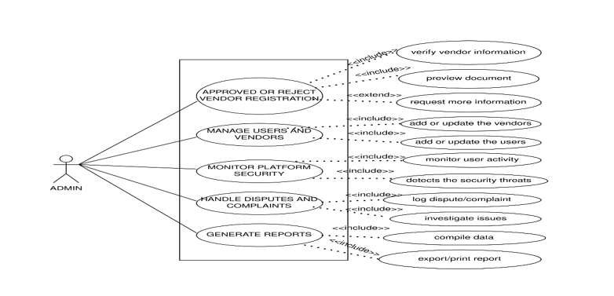

Use Case: Approve a New Vendor Registration
- Primary Actor: Admin
- Secondary Actor: System
- Preconditions:
  - Admin is logged into the admin dashboard.
  - New vendor registration requests are pending review.
- Post-conditions:
  - Vendor registration is approved or rejected.
  - Approved vendor receives notification and access credentials.
- Triggers: Admin selects a pending vendor registration to review and clicks "Approve" or "Reject."
- Main Success Scenario:
  - Admin reviews vendor details and supporting documents.
  - Admin approves the registration.
  - System updates vendor status to active.
  - Vendor receives approval notification.
- Exception Scenario:
  - Missing or invalid vendor information; admin cannot approve and is prompted to review details.
  - System error during approval process; admin is notified to try again later.

2.3.2 Vendor
- Adds and manages products
- Updates inventory
- Processes customer orders
- Views sales reports

USE CASE 2:

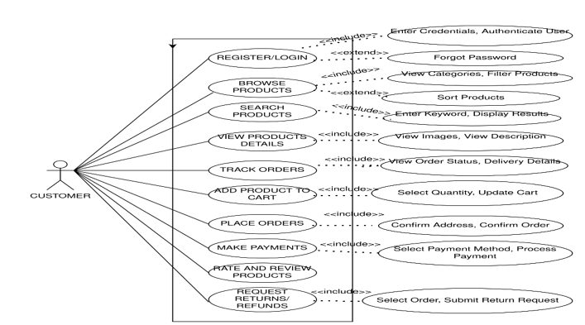

Use Case: Submit a Product for Listing
- Primary Actor: Vendor
- Secondary Actor: System
- Preconditions:
  - Vendor is logged into their vendor account.
  - Vendor has prepared product details and images.
- Post-conditions:
  - Product details are submitted and stored in the system for review.
  - Vendor receives confirmation of submission.
- Triggers: Vendor clicks the "Submit Product" button after filling in product information.
- Main Success Scenario:
  - Vendor enters all required product details and uploads images.
  - System validates the information.
  - Product is successfully submitted for review.
  - Vendor receives confirmation message.
- Exception Scenario:
  - Missing required fields or invalid data; system prompts vendor to correct the information.
  - System error during submission; vendor is notified to try again later

2.3.3 Customer
- Browses products
- Places orders
- Makes payments
- Tracks deliveries
- Reviews products

USE CASE 3:

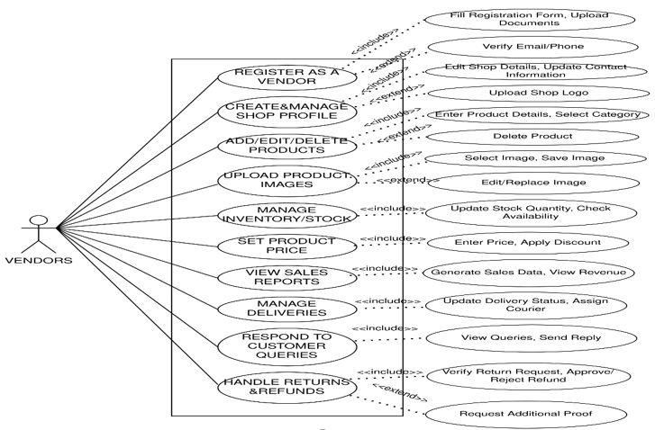

Use Case: Place an Order
- Primary Actor: Customer User
- Secondary Actor: System
- Preconditions:
  - Customer is logged into the system.
  - Shopping cart contains selected items.
- Post-conditions:
  - Order is successfully created and stored in the system.
  - Payment process is initiated or completed.
- Triggers: Customer clicks the "Place Order" or "Checkout" button.
- Main Success Scenario:
  - Customer reviews order details and confirms.
  - System validates cart and payment information.
  - System processes payment successfully.
  - Order confirmation is displayed and confirmation email is sent.
- Exception Scenario:
  - Payment fails or is declined; customer is notified to retry or use alternative payment methods.
  - Invalid or missing shipping information; system prompts customer to update details.

2.4 Operating Environment
The platform will operate on Windows 10/11 and Linux operating systems.It will support browsers such as Google Chrome,Mozilla Firefox,and Microsoft Edge.MySQL will be used for database management,with HTML,CSS,and JavaScript for the frontend and PHP/Node.js for the backend.An active internet connection is required to access the platform and perform online activities.

2.5 Design and Implementation Constraints
- Must support secure online transactions.
- Must use relational database management.
- Responsive design for mobile and desktop devices.
- Data privacy regulations must be followed.

2.6 User Documentation
The system will provide a User Manual to guide customers in using the platform.A Vendor Guide will help vendors manage products,orders,and their accounts.An Administrator Guide will explain user,vendor,product,and system management activities.Online Help Documentation will provide quick assistance and guidance whenever required.

2.7 Assumptions and Dependencies
• Users have internet access.
• Payment gateway services are available.
• Vendors provide accurate product information.
• Delivery services are available.
3. External Interface Requirements
3.1 User Interfaces
The system provides a user-friendly interface consisting of a Home Page, Login and Registration Page, Vendor Dashboard, Customer Dashboard, Product Listing Page, Shopping Cart Page, Payment Page, Order Tracking Page, and Admin Dashboard.
3.2 Hardware Interfaces
The system can be accessed using desktop computers, laptops, smartphones, and tablets to provide convenient access to customers, vendors, and administrators.
3.3 Software Interfaces
The system will interact with the MySQL database for data management and will use Payment Gateway APIs for processing online transactions. Email Notification and SMS Notification services will be used to send important updates to users.
3.4 Communications Interfaces
The system will use HTTP/HTTPS protocols for communication between users and the application server. Internet connectivity is required to access the platform, while email communication and SMS notifications will be used to provide users with relevant updates and information.
4. System Features
This section organizes the functional requirements of the Multi Vendor E-Commerce Platform according to its major feature areas. Each feature includes a description, priority, representative user/system interaction sequences, and functional requirements that can be implemented and verified by the development and testing teams.
4.1 User Registration and Authentication
4.1.1 Description and Priority
The system allows customers, vendors, and administrators to create accounts and securely log in to the platform.The system identifies the user's role and provides access to the appropriate features and dashboard.
4.1.2 Stimulus/Response Sequences
• The user selects the Register option and enters the required personal or business details.
• The system validates the entered information and creates the account if the details are valid.
• The user enters valid login credentials and selects the Login option.
• The system authenticates the user and redirects the user to the appropriate customer, vendor, or administrator dashboard.

4.1.3 Functional Requirements
REQ-AUTH-01: The system shall allow customers and vendors to register using the required personal or business information
REQ-AUTH-02:The system shall authenticate registered users using valid login credentials.
REQ-AUTH-03:The system shall assign appropriate roles such as customer,vendor,or administrtor.
REQ-AUTH-04: The system shall prevent registration using an already registered email address.
REQ-AUTH-05: The system shall allow users to securely log out from the system.

4.2 Product Browsing and Search
4.2.1 Description and Priority
The system allows customers to browse products offered by different vendors and search for products using keywords, categories, prices, and other available filters.Priority: High
4.2.2 Stimulus/Response Sequences
• The customer opens the product catalog and the system displays available products.
• The customer enters a product name or keyword and the system displays matching products.
• The customer selects a category or filter and the system displays products according to the selected criteria.
• The customer selects a product to view its details, price, availability, vendor information, and reviews.

4.2.3 Functional Requirements
REQ-PROD-01: The system shall display active products available from registered vendors.
REQ-PROD-02: The system shall allow customers to search products using keywords.
REQ-PROD-03: The system shall allow customers to filter products by category and price.
REQ-PROD-04: The system shall display product name, description, price, image, stock availability, and vendor information.
REQ-PROD-05: The system shall display customer ratings and reviews associated with products.

4.3 Vendor and Product Management
4.3.1 Description and Priority
The system allows vendors to manage their business profiles, products, prices, product descriptions, images, and inventory through a dedicated vendor dashboard. Priority: High
4.3.2 Stimulus/Response Sequences
• The vendor logs into the vendor dashboard.
• The vendor selects the Add Product option and enters the required product details.
• The system validates the information and adds the product to the vendor's product catalog.
• The vendor can edit product information, update stock quantities, or remove products when required.

4.3.3 Functional Requirements
REQ-VEND-01: The system shall allow vendors to manage their business profiles.
REQ-VEND-02: The system shall allow vendors to add new products.
REQ-VEND-03: The system shall allow vendors to edit and delete their products.
REQ-VEND-04: The system shall allow vendors to upload product images and descriptions.
REQ-VEND-05: The system shall allow vendors to update product prices and stock quantities.
REQ-VEND-06: The system shall allow administrators to verify and manage vendor accounts.

4.4 Shopping Cart and Order Management
4.4.1 Description and Priority
The system allows customers to add products from different vendors to a shopping cart, modify quantities, place orders, and view their order history.Priority: High
4.4.2 Stimulus/Response Sequences
• The customer selects a product and clicks Add to Cart.
• The system adds the selected product to the customer's shopping cart.
• The customer reviews the cart and changes product quantities if required.
• The customer proceeds to checkout and provides the required delivery information.
• The system creates the order after successful order confirmation and payment.
4.4.3 Functional Requirements
REQ-ORD-01: The system shall allow customers to add products to the shopping cart.
REQ-ORD-02: The system shall allow customers to update or remove products from the cart.
REQ-ORD-03: The system shall calculate the total cost of products in the cart.
REQ-ORD-04: The system shall allow customers to place orders using valid delivery information.
REQ-ORD-05: The system shall generate a unique order ID for each order.
REQ-ORD-06: The system shall allow customers to view their order history.

4.5 Online Payment Management
4.5.1 Description and Priority
The system provides secure online payment functionality that allows customers to pay for their orders using an integrated payment gateway. Priority: High
4.5.2 Stimulus/Response Sequences
• The customer proceeds to the payment page after confirming the order.
• The system displays the total payable amount.
• The customer selects an available payment method and completes the transaction.
• The payment gateway sends the transaction status to the system.
• The system records the payment status and confirms the order when payment is successful.
4.5.3 Functional Requirements
REQ-PAY-01: The system shall display the total amount payable for an order.
REQ-PAY-02: The system shall integrate with an online payment gateway.
REQ-PAY-03: The system shall record successful and failed payment transactions.
REQ-PAY-04: The system shall generate a payment confirmation for successful transactions.
REQ-PAY-05: The system shall not confirm an order as paid when the payment transaction fails.

4.6 Order Tracking and Delivery Management
4.6.1 Description and Priority
The system allows vendors and customers to monitor the status of orders from order confirmation through delivery.Priority: High
4.6.2 Stimulus/Response Sequences
• The vendor receives a newly placed order through the vendor dashboard.
• The vendor updates the order status after processing the order.
• The system displays the updated order status to the customer.
• The customer views the order tracking page to monitor the delivery progress.

4.6.3 Functional Requirements
REQ-DEL-01: The system shall allow vendors to view customer orders.
REQ-DEL-02: The system shall allow vendors to update order status.
REQ-DEL-03: The system shall display order statuses such as Confirmed, Processing, Shipped, and Delivered.
REQ-DEL-04: The system shall allow customers to track their orders.
REQ-DEL-05: The system shall maintain order and delivery status records.

5. Other Nonfunctional Requirements
5.1 Performance Requirements
• The system shall return product search results within 2 seconds under normal operating conditions.
• The system shall support multiple customers and vendors accessing the platform simultaneously without significant degradation in performance.
• The product catalog, customer dashboard, vendor dashboard, and administrator dashboard should load within 3 seconds under normal network conditions.
• The system shall process order and payment requests without unnecessary delays.
5.2 Safety Requirements
The system shall maintain accurate records of products, orders, payments, and customer information to prevent data loss or incorrect transactions. The system shall perform regular database backups to reduce the risk of losing important business and transaction information. The system shall also prevent accidental deletion of critical records through appropriate confirmation mechanisms.

5.3 Security Requirements
• The system shall authenticate customers, vendors, and administrators before allowing access to protected functions.
• The system shall enforce role-based access control so that customers, vendors, and administrators can access only the functions appropriate to their roles.
• Passwords shall be stored securely and shall not be stored as plain text.
• All sensitive data transmitted between users and the server shall be protected using HTTPS.
• Payment information shall be processed through a secure payment gateway and sensitive payment details shall not be unnecessarily stored by the application.
• The system shall maintain records of important administrative activities such as vendor verification and account management.

5.4 Software Quality Attributes

• Usability: The platform shall provide a simple and user-friendly interface that allows customers and vendors to perform their activities easily.
• Reliability: The system shall maintain accurate product, order, payment, and user information during normal operation.
• Availability: The platform shall be available to customers, vendors, and administrators whenever the service is operational.
• Maintainability: The system shall use modular components so that individual features can be updated without affecting the entire application.
• Scalability: The system shall be designed so that additional vendors, products, customers, and categories can be added as the platform grows.
• Security: The system shall protect user information, account credentials, and transaction-related data from unauthorized access.

5.5 Business Rules
• Only registered vendors shall be allowed to list products on the platform.
• Vendors must provide valid business and product information during registration and product listing.
• Vendors may manage only the products associated with their own accounts.
• Customers must be logged in to place orders and access their order history.
• Customers shall be able to review products only after purchasing them.
• An order shall be confirmed only after successful payment or according to the selected payment method.
• Vendors shall update the order status as the order progresses through processing and delivery.
• Administrators shall have system-wide access to manage users, vendors, products, orders, and platform activities.

6. Other Requirements
The system shall maintain a structured database for storing customer, vendor, product, inventory, order, payment, delivery, and review information. The database shall support future expansion of the platform, including additional product categories, vendors, payment methods, and delivery services. The system should also support future integration with mobile applications, additional payment gateways, and advanced product recommendation features without requiring major changes to the core system.

Appendix A: Analysis Models
The design phase will include supporting analysis models for the Multi Vendor E-Commerce Platform, including the Use Case Diagram, Data Flow Diagram, Class Diagram, Entity-Relationship Diagram, and relevant activity or sequence diagrams. These models will represent the interactions between customers, vendors, administrators, products, orders, payments, and deliveries..

UML DIAGRAM:

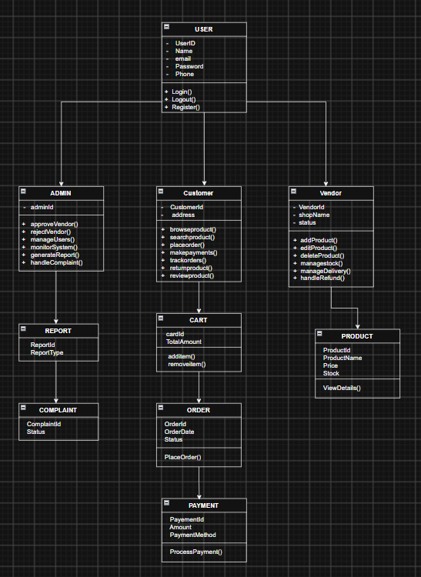

ACTIVITY DIAGRAM:
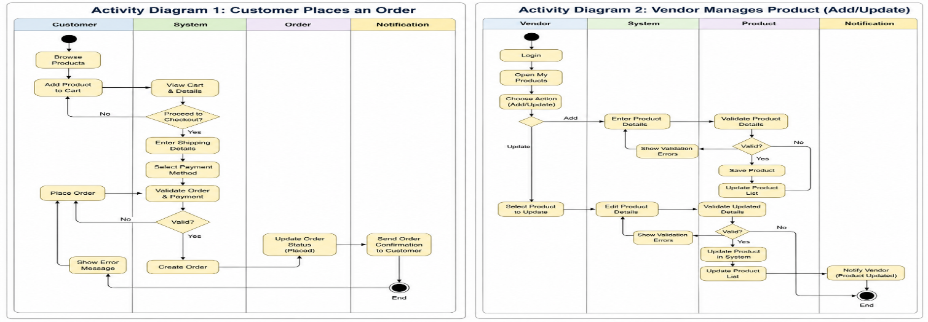
STATE DIAGRAM:

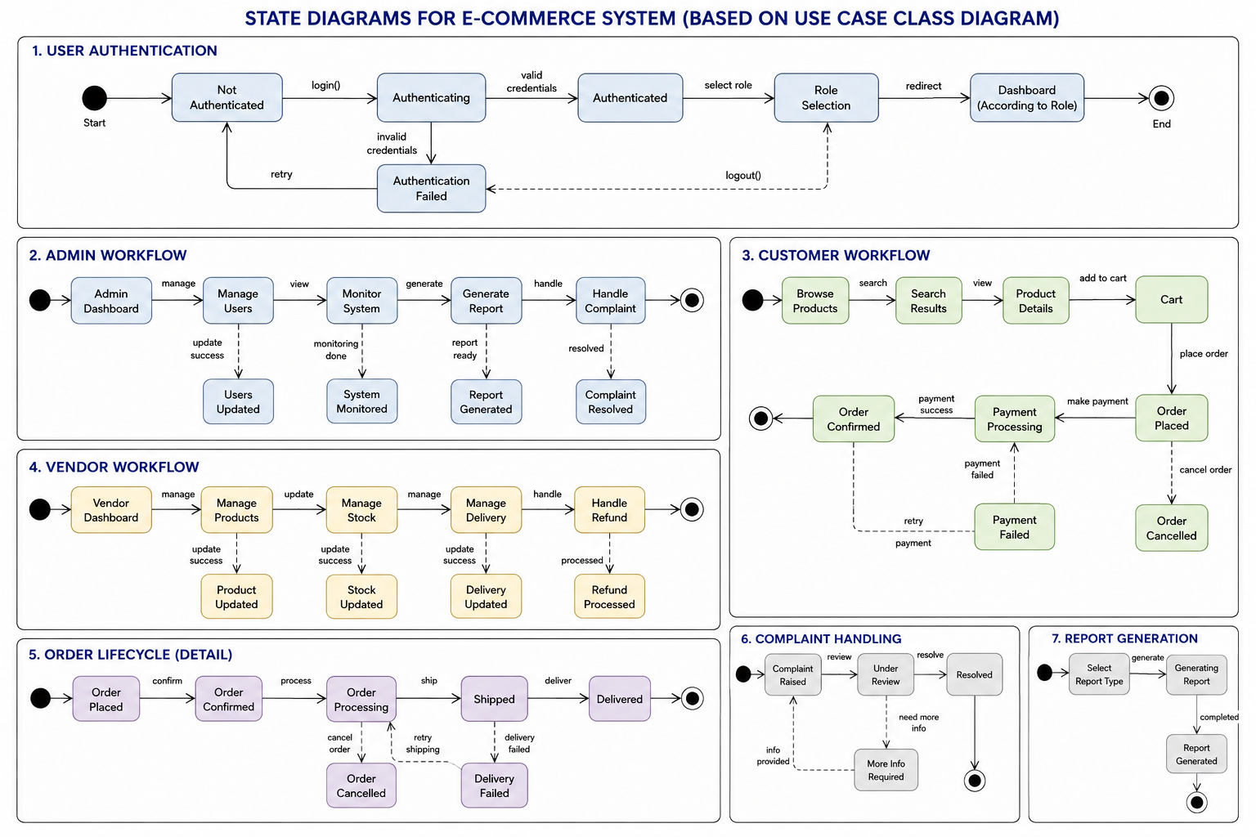
UML DEPLOYMENT DIAGRAM:

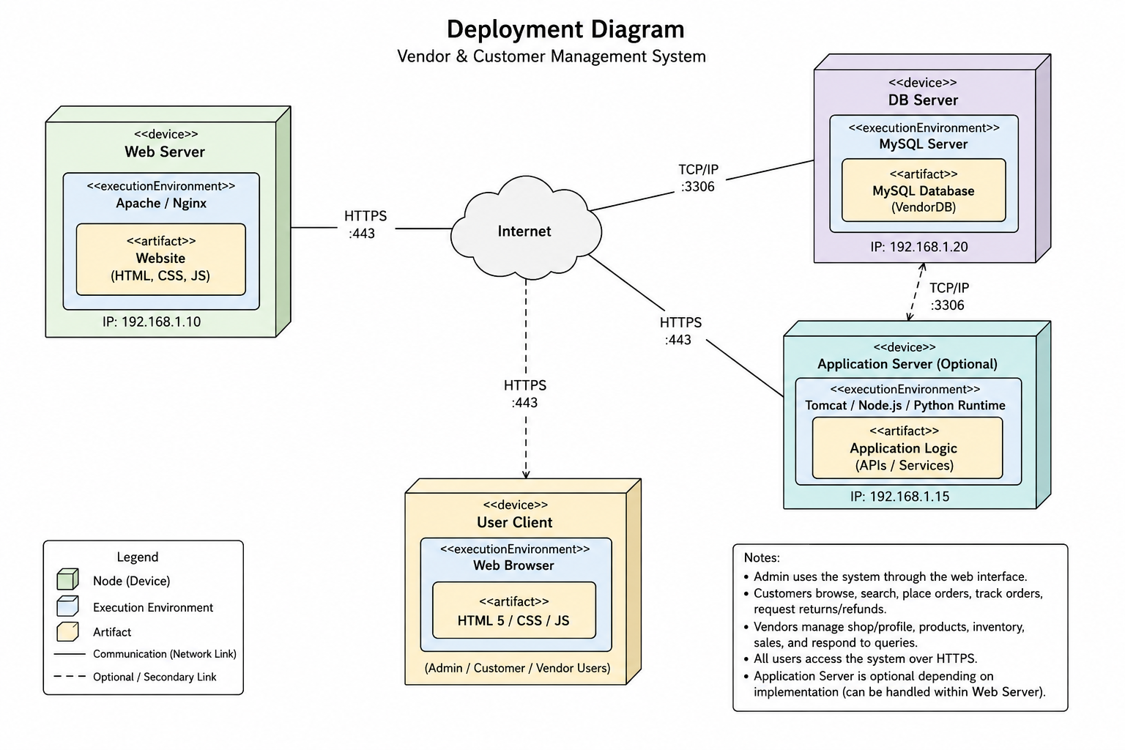
SEQUENCE DIAGRAM:
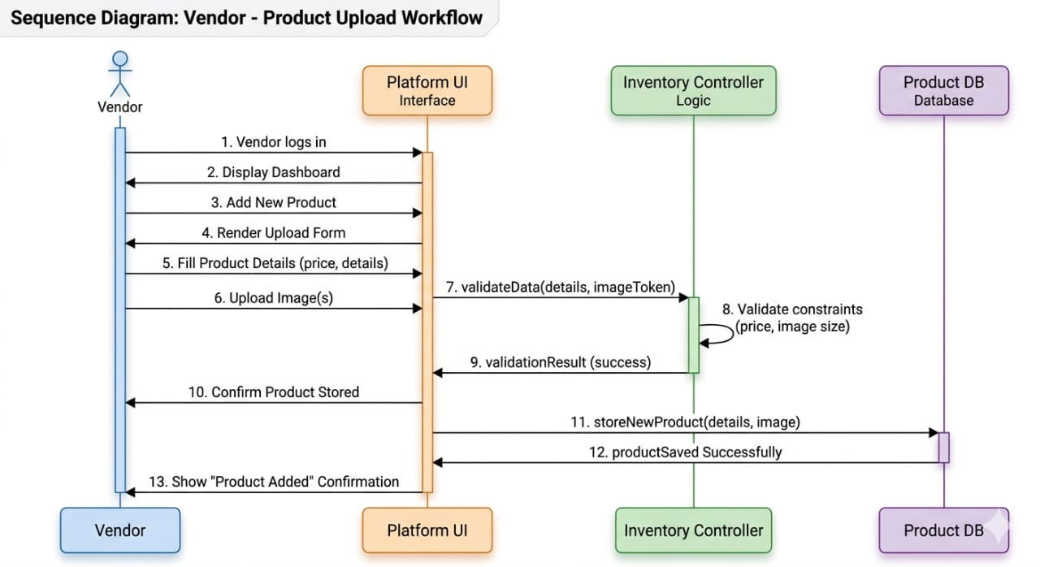
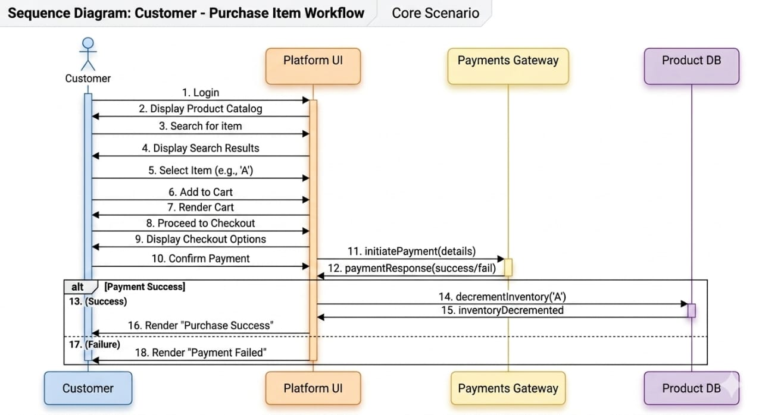

COMPONENT DIAGRAM:
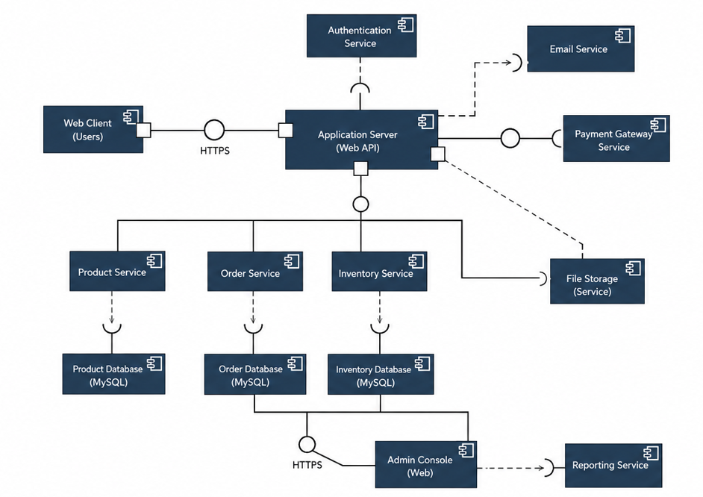
SOURCE CODE:
Admincontroller.js
const pool = require('../config/db');
async function stats(req,res) {
const [[users]] = await pool.query('SELECT COUNT(*) count FROM users');
const [[products]] = await pool.query('SELECT COUNT(*) count FROM products WHERE is_active=1');
const [[orders]] = await pool.query('SELECT COUNT(*) count FROM orders');
const [[revenue]] = await pool.query("SELECT COALESCE(SUM(total_amount),0) total FROM orders WHERE payment_status='paid'"); res.json({success:true,stats:{users:users.count,products:products.count,orders:orders.count,revenue:revenue.total}});}
async function pendingVendors(req,res) {
const [rows] = await pool.query("SELECT id,name,email,created_at FROM users WHERE role='vendor' AND vendor_status='pending'");
res.json({success:true,vendors:rows});}
async function approveVendor(req,res) {
await pool.query("UPDATE users SET vendor_status='approved' WHERE id=? AND role='vendor'",[req.params.id]);
res.json({success:true,message:'Vendor approved'});}
module.exports = {stats,pendingVendors,approveVendor};
authcontroller.js:

const bcrypt = require('bcryptjs');
const pool = require('../config/db');
const { createToken } = require('../utils/jwt');
async function register(req, res) {
try {const { name, email, password, role = 'customer' } = req.body;
if (!name || !email || !password) return res.status(400).json({ success: false, message: 'Name, email and password are required' });
if (!['customer', 'vendor'].includes(role)) return res.status(400).json({ success: false, message: 'Invalid role' });
const [exists] = await pool.query('SELECT id FROM users WHERE email=?', [email]);
if (exists.length) return res.status(409).json({ success: false, message: 'Email already registered' });
const hash=await bcrypt.hash(password, 10);
const [result]=await pool.query(
'INSERT INTO users(name,email,password_hash,role,vendor_status) VALUES(?,?,?,?,?)',
[name, email, hash, role, role === 'vendor' ? 'pending' : 'approved']);
res.status(201).json({ success: true, message: 'Registration successful', userId: result.insertId });
} catch (e) {
res.status(500).json({ success: false, message: e.message }); }}
async function login(req, res) {
try {
const { email, password } = req.body;
const [rows] = await pool.query('SELECT * FROM users WHERE email=?', [email]);
if (!rows.length || !(await bcrypt.compare(password, rows[0].password_hash))) {
return res.status(401).json({ success: false, message: 'Invalid email or password' });}
const user = rows[0];
if (user.role === 'vendor' && user.vendor_status !== 'approved') {
return res.status(403).json({ success: false, message: `Vendor account is ${user.vendor_status}` });}
const token = createToken(user);
res.json({ success: true, token, user: { id:user.id, name:user.name, email:user.email, role:user.role } });
} catch (e) {
res.status(500).json({ success: false, message: e.message });}}
module.exports = { register, login };

cartcontroller.js:

const pool = require('../config/db');
async function getCart(req,res) {
const [rows] = await pool.query(
`SELECT ci.id,ci.product_id,ci.quantity,p.name,p.price,p.image_url FROM cart_items ci JOIN carts c ON c.id=ci.cart_id JOIN products p ON p.id=ci.product_id WHERE c.customer_id=?`,[req.user.id]);
res.json({success:true,items:rows});}
async function addToCart(req,res){
const {product_id, quantity=1} = req.body;
const [carts] = await pool.query('SELECT id FROM carts WHERE customer_id=?',[req.user.id]);
let cartId = carts[0]?.id;
if(!cartId){
const [r] = await pool.query('INSERT INTO carts(customer_id)VALUES(?)',[req.user.id]);
cartId=r.insertId;}
await pool.query(`INSERT INTO cart_items(cart_id,product_id,quantity) VALUES(?,?,?) ON DUPLICATE KEY UPDATE quantity=quantity+VALUES(quantity)`,
[cartId,product_id,quantity]);
res.json({success:true,message:'Added to cart'});}
async function updateCart(req,res){
await pool.query(
`UPDATE cart_items ci JOIN carts c ON c.id=ci.cart_id SET ci.quantity=?
WHERE ci.id=? AND c.customer_id=?`,
[req.body.quantity,req.params.id,req.user.id]);
res.json({success:true});}
async function removeFromCart(req,res) {
await pool.query(
`DELETE ci FROM cart_items ci JOIN carts c ON c.id=ci.cart_id WHERE ci.id=? AND c.customer_id=?`,
[req.params.id,req.user.id]);
res.json({success:true});}
module.exports = {getCart,addToCart,updateCart,removeFromCart};

vendorcontroller.js:

const pool = require('../config/db');
async function dashboard(req,res) {
const [[sales]] = await pool.query(
`SELECT COALESCE(SUM(oi.quantity*oi.unit_price0)sales,
COUNT(DISTINCT oi.order_id) orders,
COUNT(DISTINCT oi.product_id) products
FROM order_items oi WHERE oi.vendor_id=?`,[req.user.id]);
res.json({success:true,stats:sales});}
module.exports = {dashboard};

paymentcontroller.js:

const pool = require('../config/db');
async function pay(req,res) {
const {order_id,method='demo'} = req.body;
const [orders] = await pool.query('SELECT * FROM orders WHERE id=? AND customer_id=?',[order_id,req.user.id]);
if (!orders.length) return res.status(404).json({success:false,message:'Order not found'});
const order=orders[0];
const transactionId = 'TXN-' + Date.now();
await pool.query(
'INSERT INTO payments(order_id,amount,method,transaction_id,status) VALUES(?,?,?,?,?)',
[order.id,order.total_amount,method,transactionId,'paid']);
await pool.query("UPDATE orders SET payment_status='paid' WHERE id=?",[order.id]);
res.json({success:true,message:'Payment successful',transactionId,receipt:{orderId:order.id,amount:order.total_amount}});}
module.exports = {pay};

authmiddleware.js:

const jwt = require('jsonwebtoken');
function authenticate(req, res, next) {
const header = req.headers.authorization || '';
const token = header.startsWith('Bearer ') ? header.slice(7) : null;
if (!token) return res.status(401).json({ success: false, message: 'Authentication required' });
try {req.user = jwt.verify(token, process.env.JWT_SECRET || 'change_this_secret');
next();
} catch {
res.status(401).json({ success: false, message: 'Invalid or expired token' });}}
function authorize(...roles) {
return (req, res, next) => {
if (!roles.includes(req.user.role)) {
return res.status(403).json({ success: false, message: 'Access denied' });}
next();};}
module.exports = { authenticate, authorize };

adminRoutes.js:

const router=require('express').Router();
const c=require('../controllers/adminController');
const {authenticate,authorize}=require('../middleware/authMiddleware');
router.get('/stats',authenticate,authorize('admin'),c.stats);
router.get('/vendors/pending',authenticate,authorize('admin'),c.pendingVendors);
router.put('/vendors/:id/approve',authenticate,authorize('admin'),c.approveVendor);
module.exports=router;

vendorroutes.js:

const router=require('express').Router();
const c=require('../controllers/vendorController');
const {authenticate,authorize}=require('../middleware/authMiddleware');
router.get('/dashboard',authenticate,authorize('vendor'),c.dashboard);
module.exports=router;

admin-dashboard.html:

<!DOCTYPE html>
<html lang="en">
<head><meta charset="UTF-8">
<meta name="viewport" content="width=device-width, initial-scale=1.0">
<title>Admin Governance Hub | softmulti_pro</title>
<link rel="stylesheet" href="assets/css/style.css">
</head><body>
<!-- Navigation Bar -->
<header class="navbar">
<div class="container nav-container">
<a href="index.html" class="brand">
<div class="brand-icon">⚡</div>
<div>softmulti<span>_pro</span></div>
</a><ul class="nav-links">
<li><a href="admin-dashboard.html" class="nav-link active">Admin Hub</a></li>
<li><a href="products.html" class="nav-link">Storefront</a></li></ul>
<div class="nav-actions" id="navActions"></div>
</div></header>
<main class="container section" style="padding-top: 40px;">
<!-- Welcome Header -->
<div class="card" style="margin-bottom: 28px; display: flex; justify-content: space-between; align-items: center; flex-wrap: wrap; gap: 20px;"><div>
<div class="badge badge-primary" style="margin-bottom: 8px;">SYSTEM GOVERNANCE</div>
<h1>Platform Administration</h1>
<p style="margin-top: 4px;">Supervise multi-vendor registrations, platform transactions, and ecosystem metrics.</p></div><div><span class="badge badge-emerald" style="padding: 8px 16px;">● Ecosystem Operational</span>
</div></div>
<!-- Platform KPI Metric Cards -->
<div class="grid grid-cols-4" style="margin-bottom: 30px;">
<div class="stat-card">
<div class="stat-icon" style="color:var(--accent-primary);">👥</div>
<div><div class="stat-val" id="adminUsers">0</div>
<div class="stat-label">Registered Users</div></div></div>
<div class="stat-card">
<div class="stat-icon" style="color:var(--accent-cyan); background:rgba(6,182,212,0.12); border-color:rgba(6,182,212,0.25);">🏷️</div>
<div><div class="stat-val" id="adminProducts">0</div><div class="stat-label">Listed Products</div>
</div></div><div class="stat-card">
<div class="stat-icon" style="color:var(--accent-amber); background:rgba(245,158,11,0.12); border-color:rgba(245,158,11,0.25);">📦</div>
<div><div class="stat-val" id="adminOrders">0</div>
<div class="stat-label">Platform Orders</div></div></div>
<div class="stat-card">
<div class="stat-icon" style="color:var(--accent-emerald); background:rgba(16,185,129,0.12); border-color:rgba(16,185,129,0.25);">💰</div>
<div><div class="stat-val" id="adminRevenue">₹0.00</div>
<div class="stat-label">Gross Revenue</div>
</div></div></div>
<!-- Pending Vendor Approvals -->
<div class="card">
<div style="display: flex; justify-content: space-between; align-items: center; margin-bottom: 20px;"><div>
<h2 style="font-size: 1.4rem;">Pending Vendor Approvals</h2>
<p style="font-size: 0.9rem;">Review and authorize merchant onboarding requests to maintain marketplace standard.</p>
</div></div>
<div class="table-responsive">
<table class="table-modern">
<thead><tr><th>Applicant Name</th>
<th>Email</th><th>Status</th>
<th>Governance Action</th>
</tr></thead>
<tbody id="adminVendorsTable"><tr>
<td colspan="4" style="text-align: center; padding: 30px;">Checking pending approvals...</td></tr></tbody></table>
</div></div></main>
<script src="assets/js/api.js"></script>
<script src="assets/js/dashboard.js"></script>
<script>
document.addEventListener('DOMContentLoaded', () => {
loadAdminDashboard();});
</script></body></html>

Customer-dashboard.html:

<!DOCTYPE html>
<html lang="en">
<head><meta charset="UTF-8">
<meta name="viewport" content="width=device-width, initial-scale=1.0">
<title>Customer Dashboard | softmulti_pro</title>
<link rel="stylesheet" href="assets/css/style.css">
</head><body><!-- Navigation Bar -->
<header class="navbar">
<div class="container nav-container">
<a href="index.html" class="brand">
<div class="brand-icon">⚡</div>
<div>softmulti<span>_pro</span></div></a>
<ul class="nav-links">
<li><a href="products.html" class="nav-link">Marketplace</a></li>
<li><a href="cart.html" class="nav-link">Cart</a></li>
<li><a href="customer-dashboard.html" class="nav-link active">My Orders</a></li>
</ul><div class="nav-actions" id="navActions"></div>
</div></header>
<main class="container section" style="padding-top: 40px;">
<!-- Welcome Header -->
<div class="card" style="margin-bottom: 28px; display: flex; justify-content: space-between; align-items: center; flex-wrap: wrap; gap: 20px;"><div>
<div class="badge badge-primary" style="margin-bottom: 8px;">CUSTOMER ACCOUNT</div>
<h1>Hello, <span data-user-name class="text-gradient">Customer</span></h1>
<p style="margin-top: 4px;">Logged in as: <strong data-user-email style="color: #fff;">email@domain.com</strong></p>
</div><div>
<a href="products.html" class="btn btn-primary">🛍️ Browse Catalog</a>
</div></div>
<!-- Quick Stats -->
<div class="grid grid-cols-3" style="margin-bottom: 30px;">
<div class="stat-card">
<div class="stat-icon">💰</div>
<div><div class="stat-val" id="statTotalSpent">₹0.00</div>
<div class="stat-label">Total Spent</div>
</div></div><div class="stat-card">
<div class="stat-icon">📦</div>
<div><div class="stat-val" id="statActiveOrders">0</div>
<div class="stat-label">Active Orders</div>
</div></div><div class="stat-card">
<div class="stat-icon">✅</div>
<div><div class="stat-val" id="statCompletedOrders">0</div>
<div class="stat-label">Delivered Orders</div>
</div></div></div>
<!-- Orders Section -->
<div class="card">
<div style="display: flex; justify-content: space-between; align-items: center; margin-bottom: 20px;"><div>
<h2 style="font-size: 1.4rem;">Order History & Tracking</h2>
<p style="font-size: 0.9rem;">View the current fulfillment status of your purchases across all vendors.</p>
</div></div>
<div class="table-responsive">
<table class="table-modern">
<thead><tr><th>Order ID</th>
<th>Total Amount</th>
<th>Order Status</th>
<th>Payment</th>
<th>Action</th>
</tr></thead>
<tbody id="customerOrders"><tr>
<td colspan="5" style="text-align: center; padding: 30px;">Loading your orders...</td>
</tr></tbody></table>
</div</div></main><script src="assets/js/api.js"></script>
<script src="assets/js/dashboard.js"></script>
<script>
document.addEventListener('DOMContentLoaded', () => {loadCustomerDashboard();});
</script></body></html>

Index.html:

<!DOCTYPE html>
<html lang="en"><head>
<meta charset="UTF-8">
<meta name="viewport" content="width=device-width, initial-scale=1.0">
<title>softmulti_pro | Modern Multi-Vendor Digital Marketplace</title>
<link rel="stylesheet" href="assets/css/style.css">
</head><body><!-- Navigation Bar -->
<header class="navbar">
<div class="container nav-container">
<a href="index.html" class="brand">
<div class="brand-icon">⚡</div>
<div>softmulti<span>_pro</span></div>
</a><ul class="nav-links">
<li><a href="index.html" class="nav-link active">Home</a></li>
<li><a href="products.html" class="nav-link">Marketplace</a></li>
<li><a href="#categories" class="nav-link">Sellers</a></li>
<li><a href="#features" class="nav-link">Why Us</a></li></ul>
<div class="nav-actions" id="navActions">
<!-- Rendered dynamically by api.js -->
<a href="login.html" class="btn btn-secondary btn-sm">Sign In</a>
<a href="register.html" class="btn btn-primary btn-sm">Join</a>
</div></div></header>
<!-- Hero Section -->
<section class="section" style="padding: 90px 0 60px;"><div class="container">
<div style="display: grid; grid-template-columns: 1.2fr 0.8fr; gap: 50px; align-items: center;">
<div><div class="badge badge-primary" style="margin-bottom: 20px;">
🚀 NEXT-GEN MULTI-VENDOR PLATFORM</div>
<h1 style="margin-bottom: 24px;">
One Marketplace.<br>
<span class="text-gradient">Diverse Independent Sellers.</span><br>
Unlimited Possibilities.</h1>
<p style="font-size: 1.15rem; max-width: 600px; margin-bottom: 34px;">
Shop directly from verified local farmers,skilled craft artisans,indie book sellers,andlicensed pharmacies—all united under one unified digital platform with integrated tracking.</p>
<div style="display: flex; gap: 16px; flex-wrap: wrap;">
<a href="products.html" class="btn btn-primary btn-lg">Explore Marketplace</a>
<a href="register.html" class="btn btn-secondary btn-lg">Become a Vendor</a>
</div><!-- Trust Badges -->
<div style="display: flex; gap: 32px; margin-top: 48px; border-top: 1px solid var(--border-subtle); padding-top: 24px;"><div>
<div style="font-size: 1.5rem; font-weight: 800; color: #fff;">100%</div>
<div style="font-size: 0.85rem; color: var(--text-dim);">Verified Sellers</div>
</div><div>
<div style="font-size: 1.5rem; font-weight: 800; color: #fff;">Zero</div>
<div style="font-size: 0.85rem; color: var(--text-dim);">Middleman Markups</div>
</div><div>
<div style="font-size: 1.5rem; font-weight: 800; color: #fff;">Instant</div>
<div style="font-size: 0.85rem; color: var(--text-dim);">Order Tracking</div>
</div></div></div>
<!-- Floating Showcase Card --><div>
<div class="card card-hover" style="border: 1px solid var(--border-focus); box-shadow: var(--glow-primary); padding: 30px;">
<div style="display: flex; justify-content: space-between; align-items: center; margin-bottom: 20px;">
<span class="badge badge-emerald">● PLATFORM LIVE</span>
<span style="font-size: 0.85rem; color: var(--text-dim);">Real-Time Sync</span>
</div><div style="margin-bottom: 20px;">
<imgsrc="https://images.unsplash.com/photo-154283813292c53300491e?w=700&auto=format&fit=crop" alt="Marketplace" style="border-radius: var(--radius-md); height: 210px; width: 100%; object-fit: cover;"></div>
<h3 style="color: #fff; margin-bottom: 8px;">Direct from Producer to Doorstep</h3>
<p style="font-size: 0.92rem; margin-bottom: 20px;">Browse hundreds of artisanal goods and freshly harvested produce with guaranteed quality assurance.</p>
<a href="products.html" class="btn btn-primary" style="width: 100%;">Shop Featured Collections</a>
</div></div></div></div>
</section><!-- Categories Section -->
<section class="section" id="categories" style="padding: 60px 0;">
<div class="container">
<div style="text-align: center; max-width: 650px; margin: 0 auto 50px;">
<span class="badge badge-cyan" style="margin-bottom: 12px;">ECOSYSTEM CATEGORIES</span>
<h2>Curated Multi-Vendor Hubs</h2>
<p>Connecting specialized industries and passionate producers with conscious consumers.</p>
</div><div class="grid grid-cols-4">
<!-- Farmers --><div class="card card-hover" style="text-align: center;">
<div style="font-size: 3rem; margin-bottom: 14px;">🌾</div>
<h3 style="margin-bottom: 8px;">Fresh Farmers</h3>
<p style="font-size: 0.9rem; margin-bottom: 16px;">Organic vegetables, seasonal fruits, and farm-fresh dairy straight from local growers.</p>
<a href="products.html" class="badge badge-emerald">Browse Farm</a>
</div><!-- Artisans -->
<div class="card card-hover" style="text-align: center;">
<div style="font-size: 3rem; margin-bottom: 14px;">🎨</div>
<h3 style="margin-bottom: 8px;">Handmade Crafts</h3>
<p style="font-size: 0.9rem; margin-bottom: 16px;">Bespoke pottery, woven textiles, custom leatherwork, and indigenous artwork.</p>
<a href="products.html" class="badge badge-primary">Browse Crafts</a>
</div><!-- Book Sellers -->
<div class="card card-hover" style="text-align: center;">
<div style="font-size: 3rem; margin-bottom: 14px;">📚</div>
<h3 style="margin-bottom: 8px;">Indie Bookshops</h3>
<p style="font-size: 0.9rem; margin-bottom: 16px;">Academic textbooks, rare collectibles, fiction, and programming guides.</p>
<a href="products.html" class="badge badge-amber">Browse Books</a>
</div><!-- Pharmacy -->
<div class="card card-hover" style="text-align: center;">
<div style="font-size: 3rem; margin-bottom: 14px;">💊</div>
<h3 style="margin-bottom: 8px;">Wellness & Health</h3>
<p style="font-size: 0.9rem; margin-bottom: 16px;">Licensed pharmaceutical essentials, dietary supplements, and herbal remedies.</p>
<a href="products.html" class="badge badge-rose">Browse Wellness</a>
</div></div></div>
</section><!-- Live Featured Products Grid --><section class="section" style="padding: 60px 0;"><div class="container">
<div style="display: flex; justify-content: space-between; align-items: flex-end; margin-bottom: 36px; flex-wrap: wrap; gap: 16px;">
<div><span class="badge badge-primary" style="margin-bottom: 10px;">FEATURED PRODUCTS</span>
<h2>Explore Top Picks Today</h2>
</div><a href="products.html" class="btn btn-secondary">View Full Catalog →</a>
</div><div class="grid grid-auto" id="productGrid">
<!-- Rendered live by products.js -->
</div></div></section>
<!-- Platform Highlights -->
<section class="section" id="features" style="padding: 70px 0; background: var(--bg-secondary); border-top: 1px solid var(--border-subtle); border-bottom: 1px solid var(--border-subtle);"><div class="container">
<div class="grid grid-cols-3">
<div class="card"><div class="stat-icon" style="margin-bottom: 18px;">🛡️</div>
<h3 style="margin-bottom: 8px;">Escrow & Secure Transactions</h3>
<p>Customer payments are securely held until order fulfillment is verified, protecting both buyers and vendors.</p>
</div><div class="card">
<div class="stat-icon" style="margin-bottom: 18px;">📍</div><h3 style="margin-bottom: 8px;">Real-Time Status Stepper</h3>
<p>Track every step of the order lifecycle: Placed, Confirmed, Packed, Shipped, and Delivered with notifications.</p>
</div><div class="card">
<div class="stat-icon" style="margin-bottom: 18px;">⚡</div><h3 style="margin-bottom: 8px;">Seller Empowerment Hub</h3><p>Vendors receive automated stock controls, instant sales dashboards, and order dispatch management tools.</p>
</div></div></div></section>
<!-- Footer --><footer class="footer">
<div class="container">
<div class="footer-grid">
<div class="footer-col">
<div class="brand" style="margin-bottom: 14px;"><div class="brand-icon">⚡</div>
<div>softmulti<span>_pro</span></div>
</div><p style="font-size: 0.9rem; max-width: 320px;">
The full-stack multi-vendor commerce platform engineered for independent businesses and modern digital consumers.
</p></div><div class="footer-col">
<h4>Marketplace</h4>
<ul class="footer-links">
<li><a href="products.html">All Products</a></li><li><a href="products.html">Agriculture</a></li>
<li><a href="products.html">Handmade Crafts</a></li>
<li><a href="products.html">Book Stores</a></li> </ul></div>
<div class="footer-col">
<h4>Dashboards</h4>
<ul class="footer-links">
<li><a href="customer-dashboard.html">Customer Hub</a></li>
<li><a href="vendor-dashboard.html">Vendor Center</a></li>
<li><a href="admin-dashboard.html">Administrator</a></li>
<li><a href="order-tracking.html">Track Order</a></li></ul></div>
<div class="footer-col">
<h4>Account</h4><ul class="footer-links">
<li><a href="login.html">Sign In</a></li>
<li><ahref="register.html">Register</a></li>
<li><a href="cart.html">View Cart</a></li>
</ul></div></div><div class="footer-bottom"><div>&copy; 2026 softmulti_pro &mdash; Multi Vendor Digital E-Commerce Platform.</div><div>Built for Academic & Commercial Excellence</div> </div></div></footer>
<script src="assets/js/api.js"></script>
<script src="assets/js/products.js"></script>
<script>document.addEventListener('DOMContentLoaded',()=>{fetchProducts();});
</script></body></html>

Vendor-dashboard.html:

<!DOCTYPE html>
<html lang="en">
<head>
<meta charset="UTF-8">
<meta name="viewport" content="width=device-width, initial-scale=1.0">
<title>Vendor Dashboard | softmulti_pro</title>
<link rel="stylesheet" href="assets/css/style.css">
</head><body>
<!-- Navigation Bar -->
<header class="navbar">
<div class="container nav-container">
<a href="index.html" class="brand">
<div class="brand-icon">⚡</div>
<div>softmulti<span>_pro</span></div>
</a><ul class="nav-links">
<li><a href="vendor-dashboard.html" class="nav-link active">Vendor Hub</a></li>
<li><a href="vendor-products.html" class="nav-link">Product Catalog</a></li>
<li><a href="products.html" class="nav-link">Public Store</a></li></ul>
<div class="nav-actions" id="navActions"></div>
</div></header>
<main class="container section" style="padding-top: 40px;">
<!-- Welcome Header -->
<div class="card" style="margin-bottom: 28px; display: flex; justify-content: space-between; align-items: center; flex-wrap: wrap; gap: 20px;">
<div><div class="badge badge-emerald" style="margin-bottom: 8px;">VERIFIED SELLER PORTAL</div>
<h1>Welcome, <span data-user-name class="text-gradient">Vendor</span></h1>
<p style="margin-top: 4px;">Manage your multi-vendor store inventory, customer orders, and status dispatches.</p>
</div><div>
<a href="vendor-products.html" class="btn btn-primary">➕ Manage & Add Products</a>
</div></div><!-- Vendor KPI Stat Cards -->
<div class="grid grid-cols-3" style="margin-bottom: 30px;"><div class="stat-card">
<div class="stat-icon" style="color:var(--accent-emerald); background:rgba(16,185,129,0.12); border-color:rgba(16,185,129,0.25);">
💵</div><div><div class="stat-val" id="vendorSales">₹0.00</div>
<div class="stat-label">Total Realized Sales</div></div></div>
<div class="stat-card">
<div class="stat-icon">📦</div><div>
<div class="stat-val" id="vendorOrderCount">0</div>
<div class="stat-label">Orders Received</div></div></div>
<div class="stat-card">
<div class="stat-icon" style="color:var(--accent-cyan); background:rgba(6,182,212,0.12); border-color:rgba(6,182,212,0.25);">
🏷️</div><div><div class="stat-val" id="vendorProductCount">0</div>
<div class="stat-label">Active Store Items</div></div></div></div>
<!-- Incoming Orders & Dispatch Controls --><div class="card">
<div style="display: flex; justify-content: space-between; align-items: center; margin-bottom: 20px;">
<div><h2 style="font-size: 1.4rem;">Incoming Orders & Dispatch Fulfillment</h2>
<p style="font-size: 0.9rem;">Change status as you pack and ship to notify the customer in real-time.</p></div></div>
<div class="table-responsive">
<table class="table-modern">
<thead><tr><th>Order ID</th>
<th>Customer</th>
<th>Total Amount</th>
<th>Current Status</th>
<th>Dispatch Action</th>
</tr></thead>
<tbody id="vendorOrdersTable"><tr>
<td colspan="5" style="text-align: center; padding: 30px;">Loading customer orders...</td></tr></tbody></table>
</div></div></main><script src="assets/js/api.js"></script>
<script src="assets/js/dashboard.js"></script>
<script>document.addEventListener('DOMContentLoaded', () => { loadVendorDashboard();});
</script></body></html>

Register.html:

<!DOCTYPE html>
<html lang="en">
<head>
<meta charset="UTF-8">
<meta name="viewport" content="width=device-width, initial-scale=1.0">
<title>Join Marketplace | softmulti_pro</title>
<link rel="stylesheet" href="assets/css/style.css">
</head><body style="display:flex; flex-direction:column; justify-content:center; align-items:center; min-height:100vh; padding: 20px 0;">
<div class="container" style="max-width: 500px; width: 100%;">
<div style="text-align: center; margin-bottom: 26px;">
<a href="index.html" class="brand" style="justify-content: center; margin-bottom: 12px;">
<div class="brand-icon">⚡</div>
<div>softmulti<span>_pro</span></div>
</a><p>Create your unified marketplace account</p></div>
<!-- Registration Card -->
<div class="card" style="box-shadow: 0 20px 45px rgba(0,0,0,0.5);">
<h2 style="margin-bottom: 6px; font-size: 1.5rem;">Create Your Account</h2>
<p style="font-size: 0.9rem; margin-bottom: 24px;">Join thousands of buyers and sellers on softmulti_pro.</p>
<form id="registerForm">
<div class="form-group">
<label for="name">Full Name or Business Name</label>
<input type="text" id="name" name="name" class="form-control" placeholder="e.g. John Doe or Green Valley Organics" required>
</div><div class="form-group">
<label for="email">Email Address</label>
<input type="email" id="email" name="email" class="form-control" placeholder="name@domain.com" required>
</div><div class="form-group">
<label for="password">Create Password</label>
<input type="password" id="password" name="password" class="form-control" placeholder="Minimum 6 characters" required></div>
<div class="form-group">
<label for="role">Select Your Role</label>
<select id="role" name="role" class="form-control" required onchange="handleRoleNotice(this.value)">
<option value="customer" selected>Customer (Browse & Purchase)</option>
<option value="vendor">Vendor (Sell Products & Manage Orders)</option>
</select></div>
<div id="vendorNotice" style="display: none; background: rgba(245, 158, 11, 0.1); border: 1px solid rgba(245, 158, 11, 0.3); border-radius: var(--radius-sm); padding: 12px; margin-bottom: 20px; font-size: 0.85rem; color: #fbbf24;">
ℹ️ <strong>Note for Vendors:</strong> Vendor registrations undergo automated and administrative approval before listings are published to the live marketplace.
</div><button type="submit" class="btn btn-primary" style="width: 100%; padding: 12px;">
Complete Registration
</button></form>
<div style="text-align: center; margin-top: 24px; padding-top: 20px; border-top: 1px solid var(--border-subtle); font-size: 0.9rem;">
<span style="color: var(--text-muted);">Already have an account?</span>
<a href="login.html" style="color: var(--accent-cyan); font-weight: 700; margin-left: 6px;">Sign In</a>
</div></div></div>
<script src="assets/js/api.js"></script>
<script src="assets/js/auth.js"></script>
<script>
function handleRoleNotice(role) {
const notice = document.getElementById('vendorNotice');
if (notice) notice.style.display = role === 'vendor' ? 'block' : 'none';}
</script></body></html>

Login.html:

<!DOCTYPE html>
<html lang="en">
<head><meta charset="UTF-8">
<meta name="viewport" content="width=device-width, initial-scale=1.0"><title>Sign In | softmulti_pro</title>
<link rel="stylesheet" href="assets/css/style.css">
</head><body style="display:flex; flex-direction:column; justify-content:center; align-items:center; min-height:100vh; padding: 20px 0;">
<div class="container" style="max-width: 480px; width: 100%;">
<div style="text-align: center; margin-bottom: 28px;">
<a href="index.html" class="brand" style="justify-content: center; margin-bottom: 12px;"><div class="brand-icon">⚡</div>
<div>softmulti<span>_pro</span></div>
</a><p>Log in to access your custom role dashboard</p></div>
<!-- Quick Demo Logins Banner -->
<div class="card" style="margin-bottom: 20px; padding: 18px; border-color: rgba(99, 102, 241, 0.4); background: rgba(99, 102, 241, 0.08);">
<div style="font-size: 0.82rem; font-weight: 700; color: #818cf8; text-transform: uppercase; margin-bottom: 10px; display: flex; align-items: center; gap: 6px;">
⚡ Instant 1-Click Demo Accounts:</div>
<div style="display: flex; gap: 8px; flex-wrap: wrap;"><button type="button" class="btn btn-secondary btn-sm" onclick="fillDemo('customer')">👤 Customer</button><button type="button" class="btn btn-secondary btn-sm" onclick="fillDemo('vendor')">🏪 Vendor</button><button type="button" class="btn btn-secondary btn-sm" onclick="fillDemo('admin')">🛡️Admin</button></div></div><!LoginFormCard-><divclad" style="box-shadow: 0 20px 45px rgba(0,0,0,0.5);">
<h2 style="margin-bottom: 6px; font-size: 1.5rem;">Welcome Back</h2>
<p style="font-size: 0.9rem; margin-bottom: 24px;">Enter your credentials below to continue</p><form id="loginForm">
<div class="form-group">
<label for="email">Email Address</label>
<input type="email" id="email" name="email" class="form-control" placeholder="name@domain.com"required></div><div class="form-group"><label for="password">Password</label>
<input type="password" id="password" name="password" class="form-control" placeholder="••••••••" required>
</div><button type="submit" class="btn btn-primary" style="width: 100%; padding: 12px; margin-top: 6px;">Sign In to Account
</button></form><div style="text-align: center; margin-top: 24px; padding-top: 20px; border-top: 1px solid var(--border-subtle); font-size: 0.9rem;">
<span style="color: var(--text-muted);">New to softmulti_pro?</span>
<a href="register.html" style="color: var(--accent-cyan); font-weight: 700; margin-left: 6px;">Create Account</a>
</div></div></div><script src="assets/js/api.js"></script>
<script src="assets/js/auth.js"></script>
</body></html>

DEMONSTRATION:

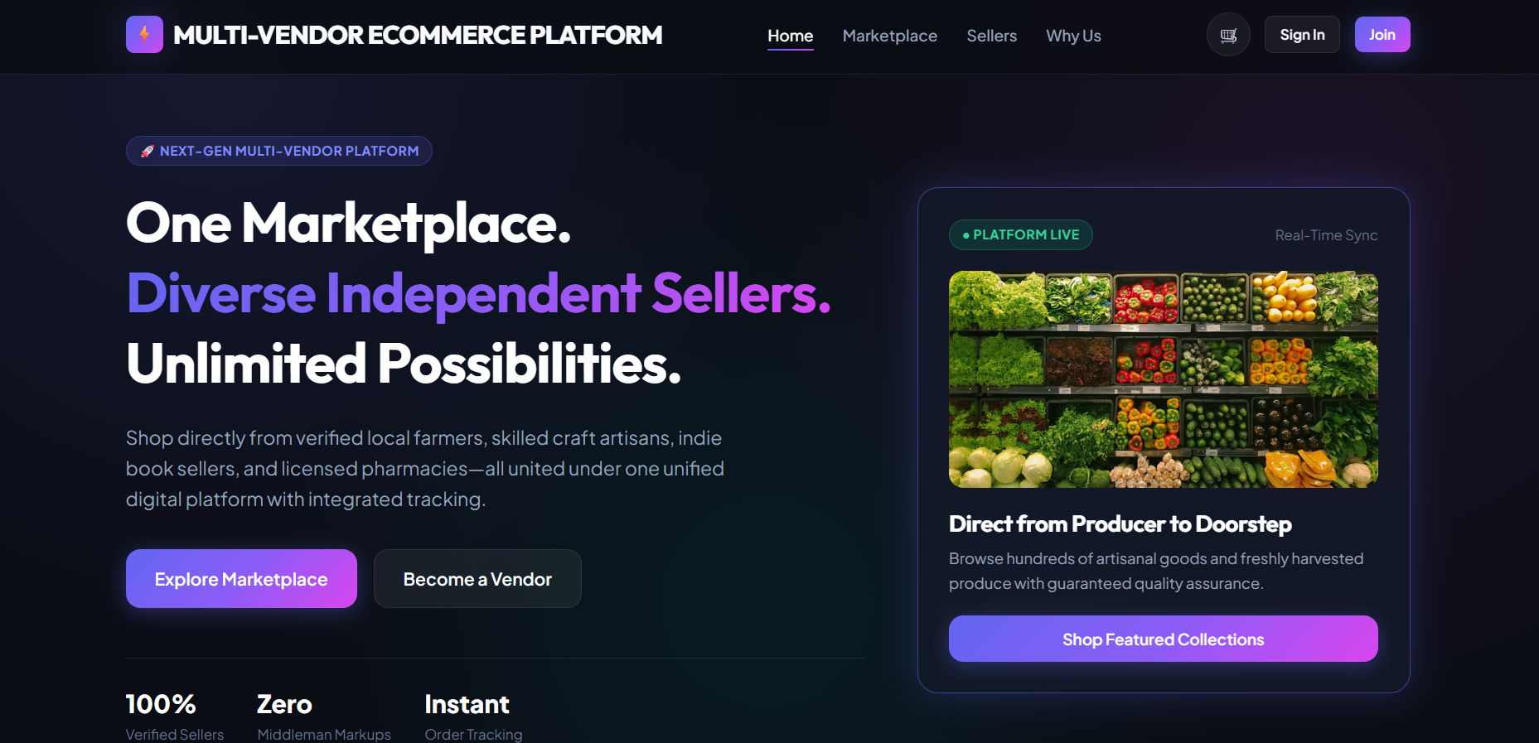
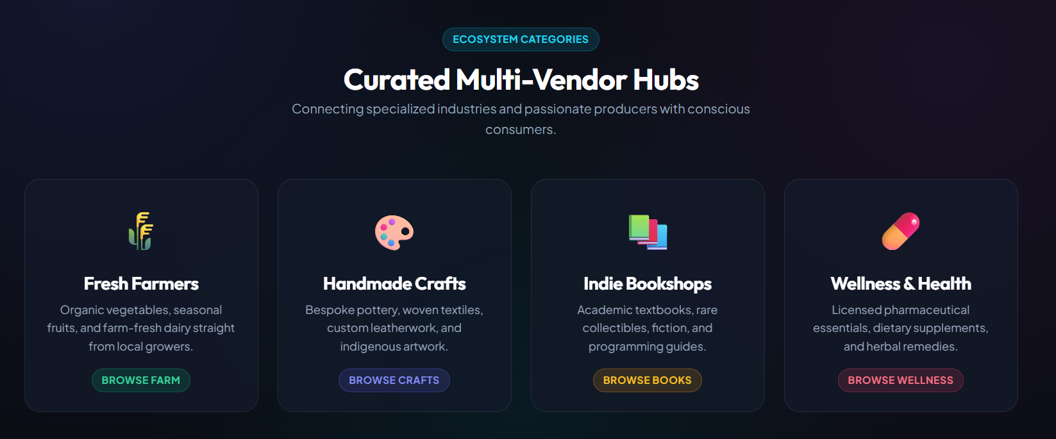
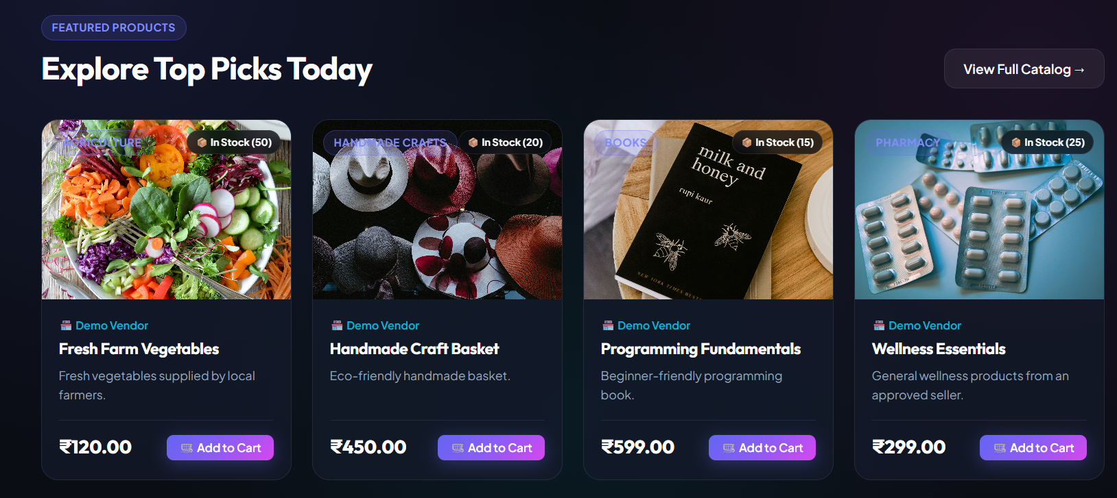
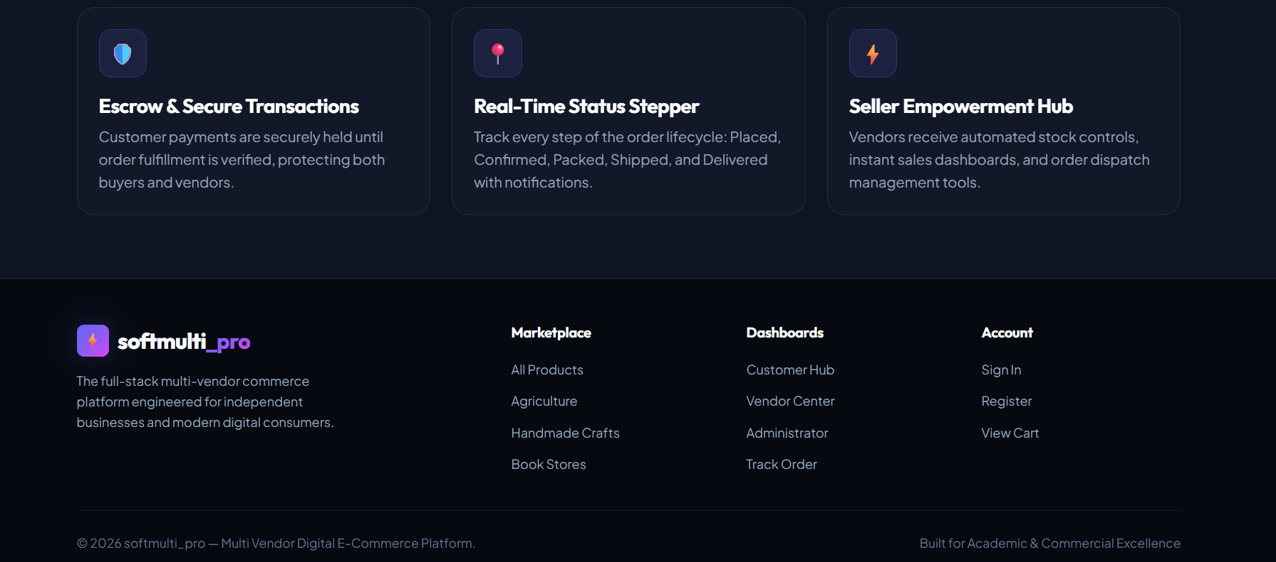

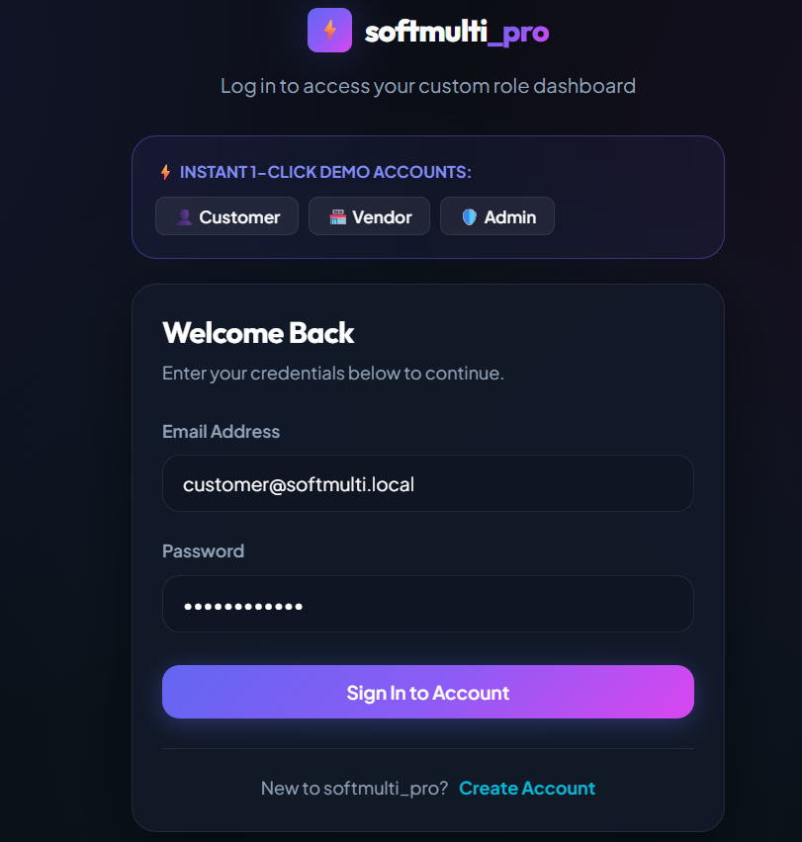
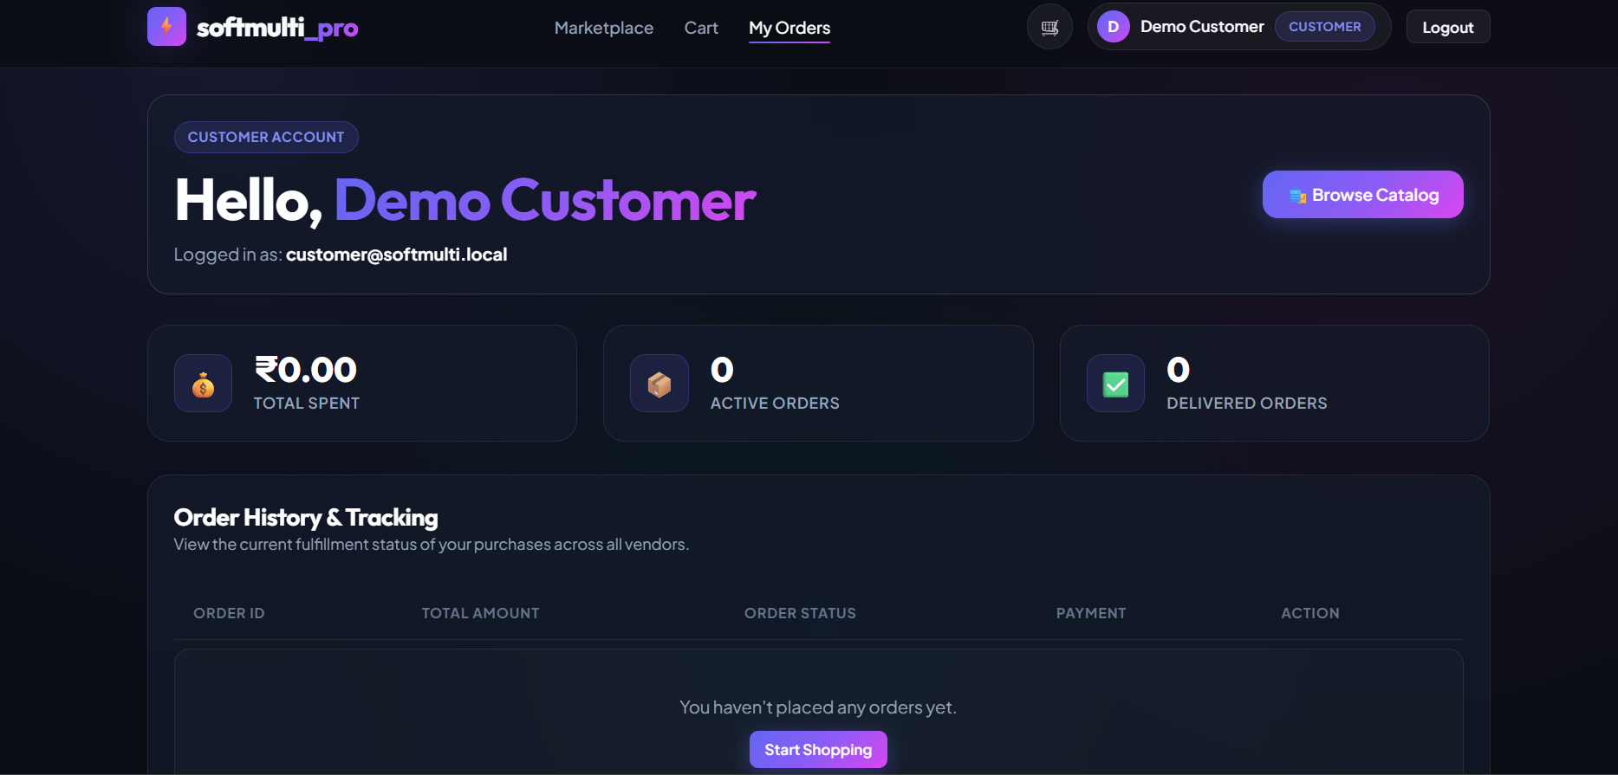
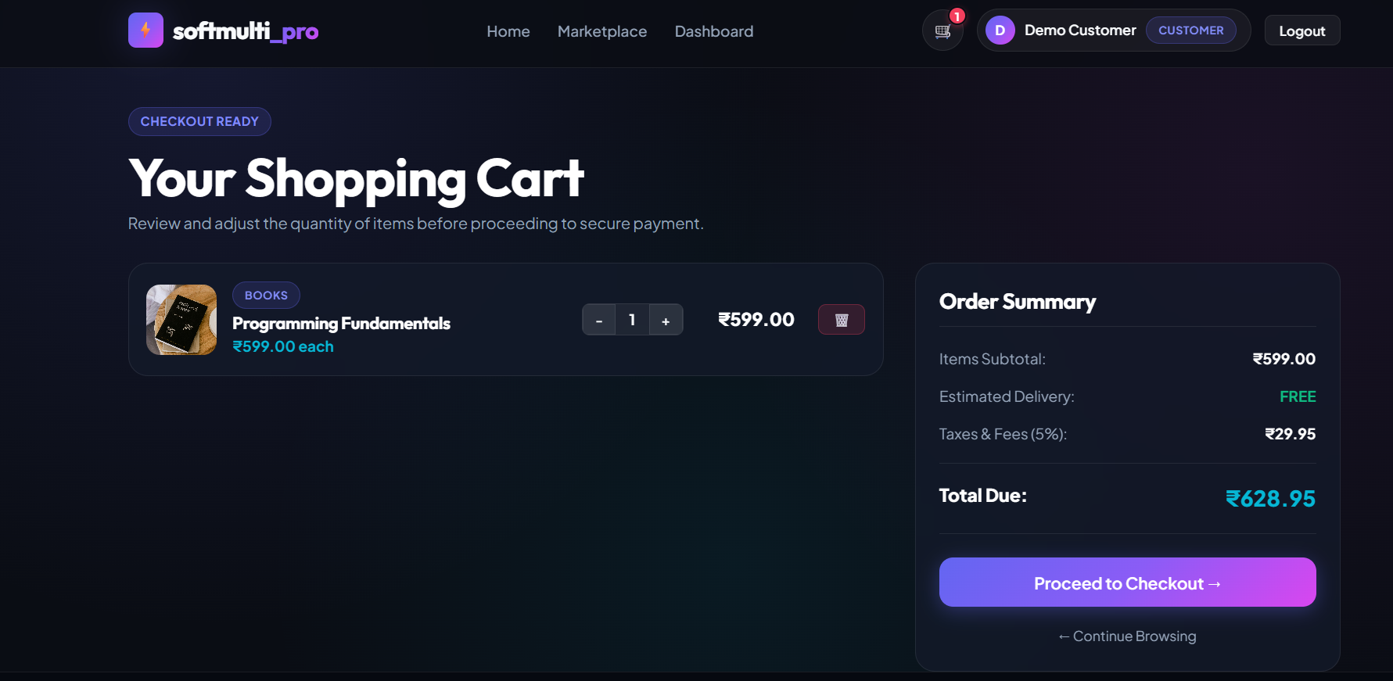
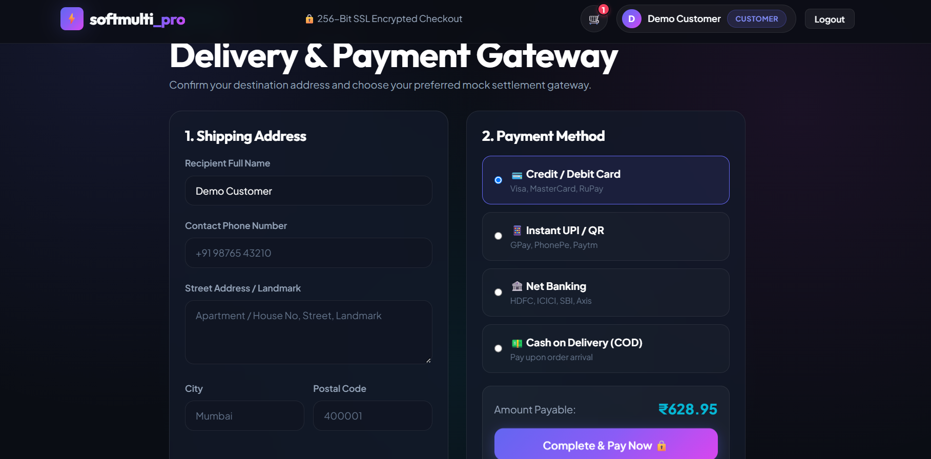
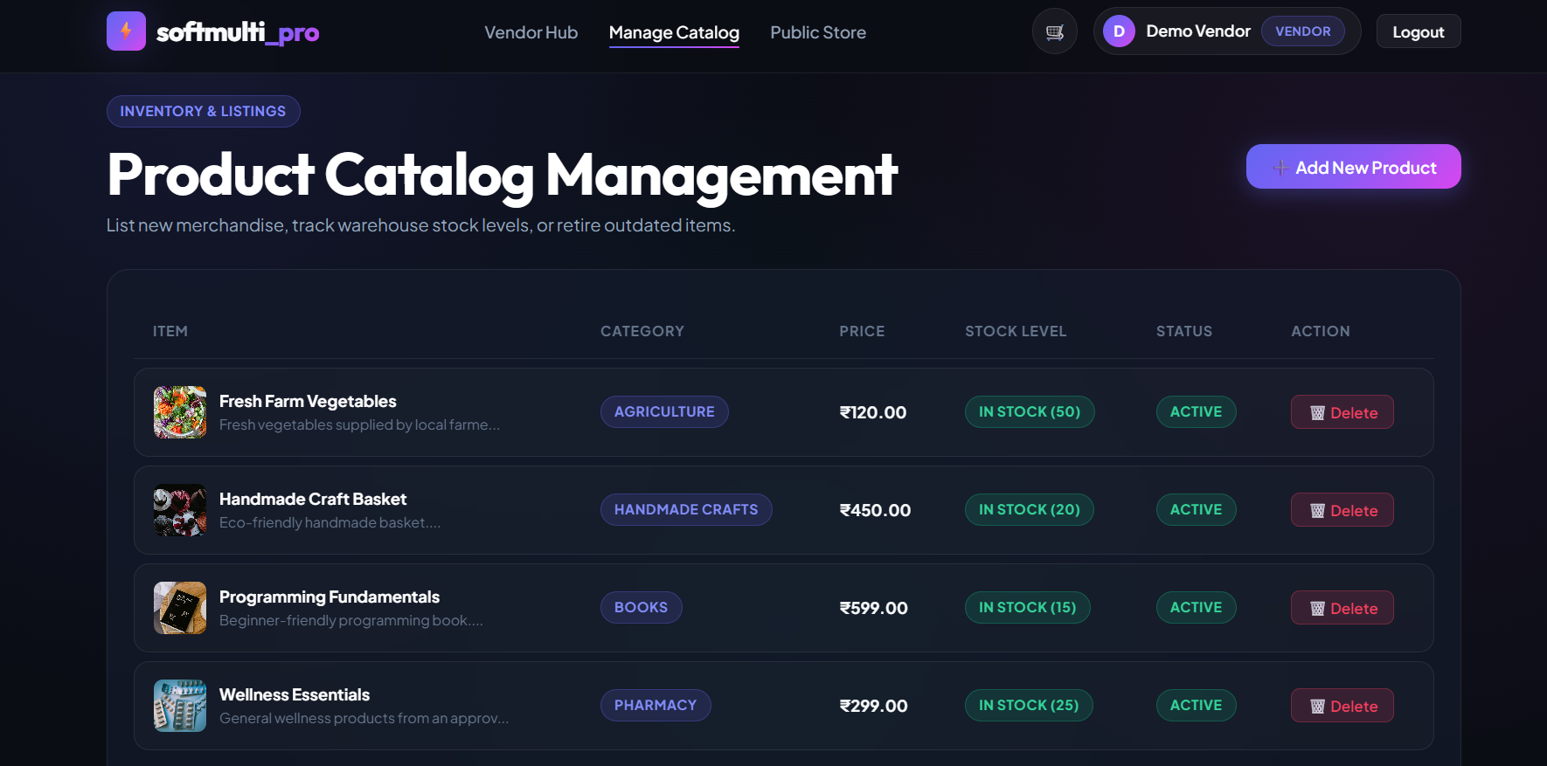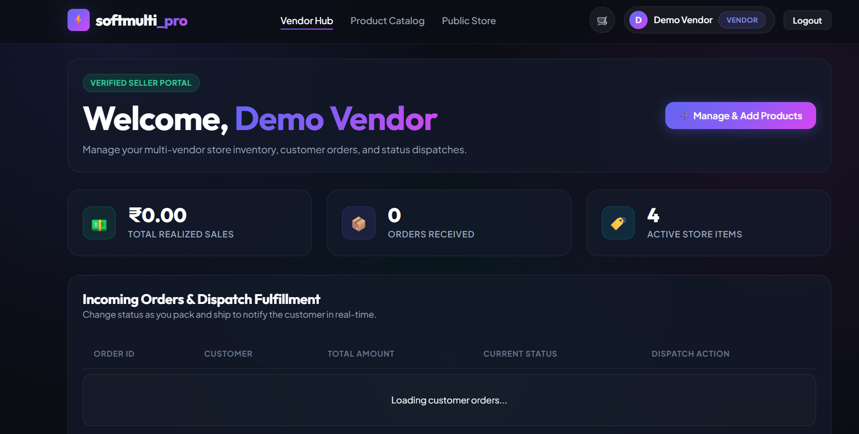
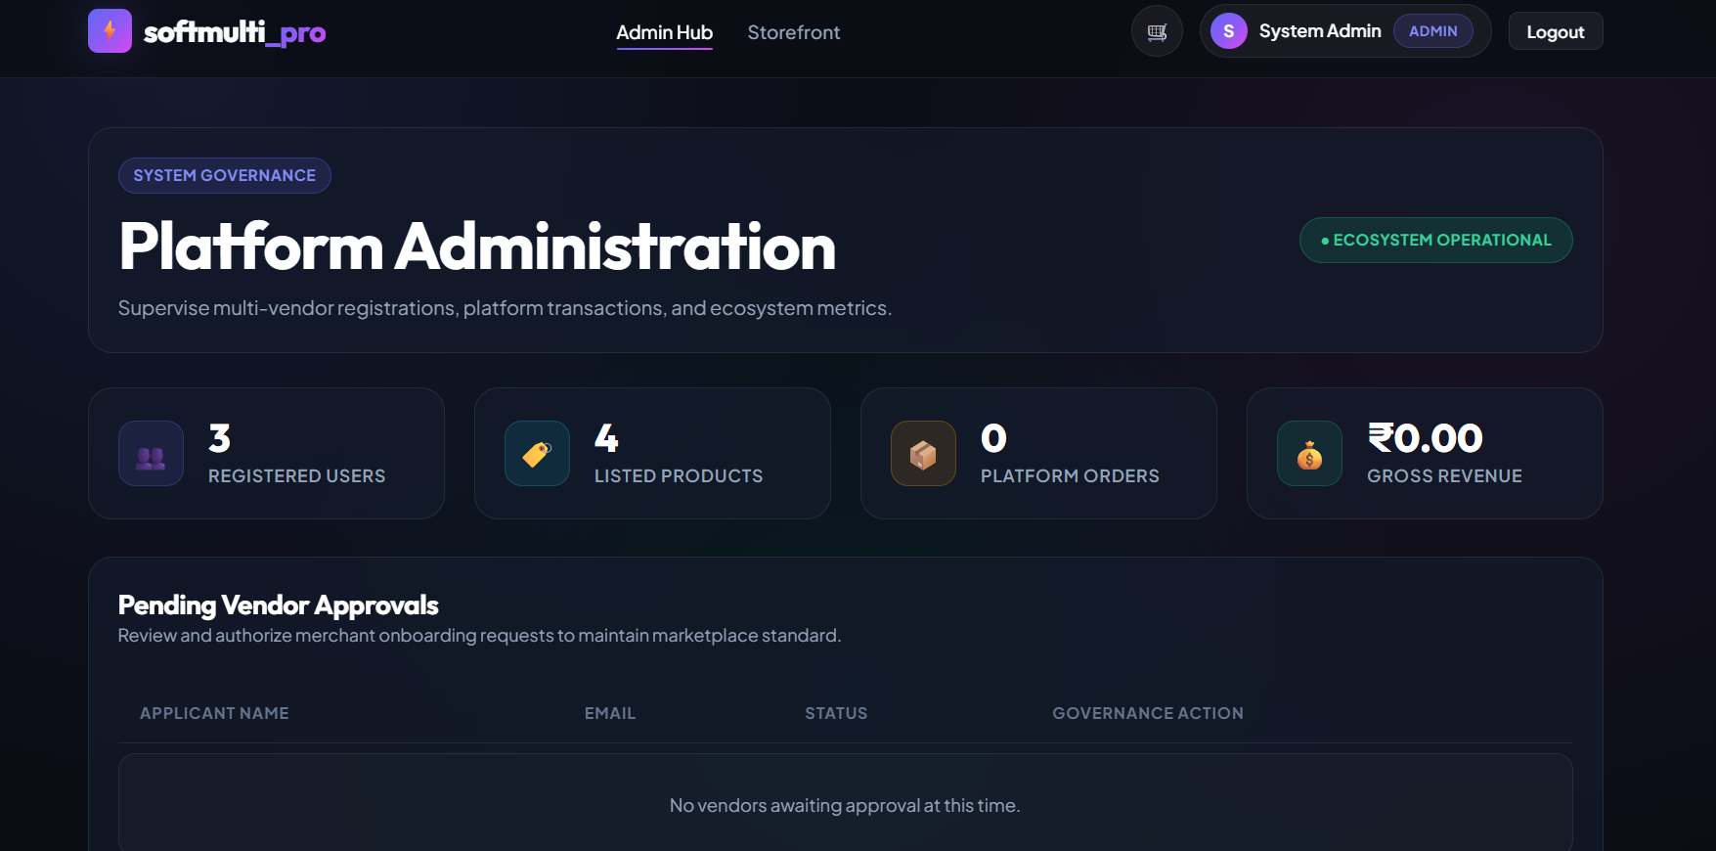

E-RESOURCE:GITHUB LINK: https://github.com/gurupriyar2007/MULTI-VENDOR-ECOMMERCE-PLATFORM.git

